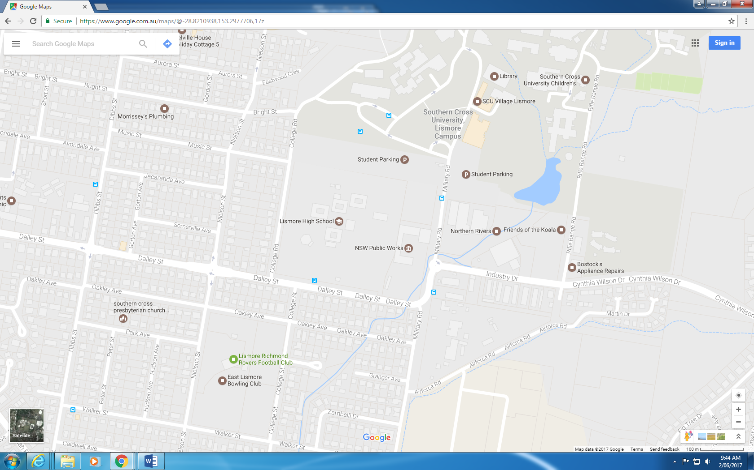

*Hall – Science, CAPA, TAS, and PDHPE*

*Staff parking*

*Staff parking*

**Combined Stage 6 Parent Teacher Evening**

**Tuesday 25th June 2019 3:30pm – 6:30pm @ Lismore High Campus**

*Library and E Block – English, Maths, HSIE*

**We look forward to meeting you at this event.**

*Staff parking*

*Parent parking*

*Parent parking*

*Parent parking*

*Parent parking*

*Parent parking*